You Are My King (주 나의 왕)
E/G# A2 Bsus B
I'm forgiven, because You were forsaken
주 날 위해 버림 받으심으로
E/G# A2 Bsus B
I'm accepted; You were condemned
나 용서 받고 용납됐네
E/G# A2 Bsus B
I'm alive and well, Your Spirit is within me
날 위해 죽으시고 부활하신 주의
A2 B E
Because you died and rose again
성령 내 안에 계시네
A E Bsus B
Amazing love, how can it be, that You my king would die for me?
오 놀라운 주의 사랑 날 위해 죽으신 주
E A E Bsus B
Amazing love, I know it's true, and it's my joy to honor You
오 놀라운 주의 사랑 기쁨으로 경배해
A B E
In all I do, I honor You
내 삶 다해 주 경배해
E
You are my king, (Jesus,) You are my king
주 나의 왕, (예수) 주 나의 왕
Used by Permission. CCLI #11103902 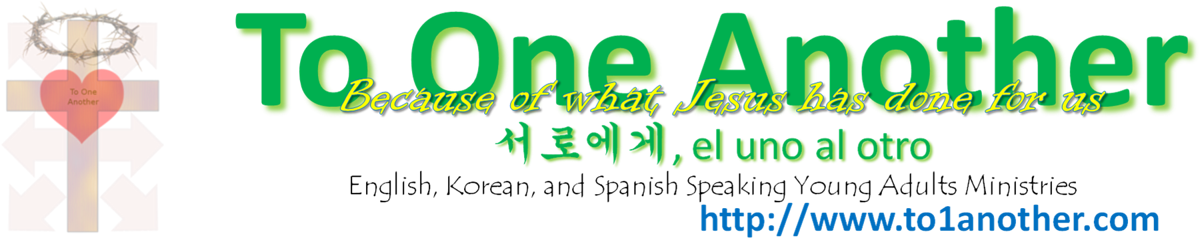
Used by Permission. CCLI #11103902
Used by Permission. CCLI #11103902
Used by Permission. CCLI #11103902
Used by Permission. CCLI #11103902
Used by Permission. CCLI #11103902
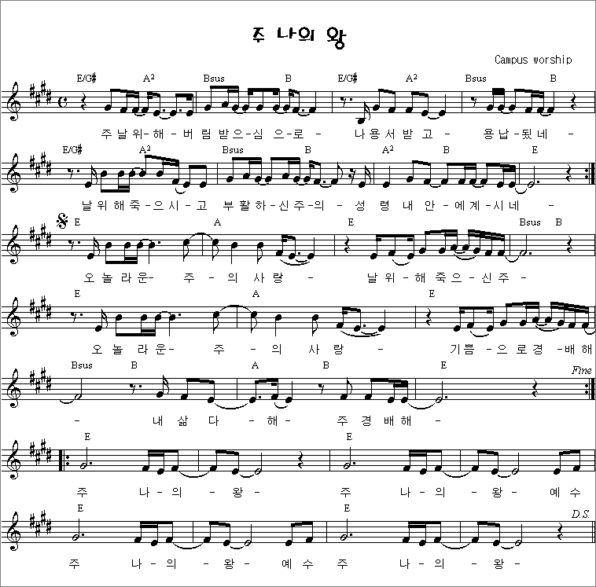
Used by Permission. CCLI #11103902

